LABORATORY MANUAL
FOR
COMPUTER HARDWARE

s/n | List of practicals | page
1 | Study of layout of motherboard and different Components. | 1-4
2 | Study of expansion slots, bus structure and ports with color codes. | 5-38
3 | Study of functioning of SMPS with o/p voltage and connector | 39-41
4 | Study of HDD Interfaces | 42-43
5 | Connecting hardware components for assembly of computer | 44-45
6 | Setting up of CMOS | 46-47
7 | Installing OS | 48-50
8 | Installing different software | 51-53
9 | Study different BIOS setup and different | 54-55
10 | Perform trouble shooting in Desktop and Laptop | 56-57

EXPERIMENT-1
AIM: Studying the layout of a motherboard and its components can be an exciting and educational experiment, especially if you're exploring the inner workings of a computer system. Here's a step-by-

step guide for conducting this experiment:

Materials Needed:
Desktop Computer: A desktop computer where you can access and examine the motherboard.
Screwdriver: To open the computer case.
Anti-static wrist strap (optional): To prevent electrostatic discharge that could harm the components.
Guide or Diagram: A motherboard layout diagram or guide for reference (online resources or the motherboard's manual).

Experiment Steps:
- Preparation:
Power off the computer and unplug it from the power source. Place the computer on a stable surface with sufficient lighting.

Opening the Case:
Use a screwdriver to remove the screws securing the side panel of the computer case.
Slide or remove the side panel to access the internal components.
- Locating the Motherboard:
Identify the large, flat circuit board inside the computer—that's the motherboard.

Visual Inspection:
Observe the layout of the motherboard. Take note of its size, shape, and the arrangement of components.
1

Identify the CPU socket, RAM slots, expansion slots, chipset, power connectors, I/O ports, and other components mentioned earlier.

Component Identification:
Refer to a motherboard layout diagram or guide to identify each component on the motherboard. This will help you understand their functions and locations.
an overview of the common components and their general layout on a standard desktop motherboard.

CPU Socket: Located at the center, this socket holds the processor (CPU). It's a crucial component that performs all the processing tasks.

RAM Slots: These slots are nearby the CPU socket and hold the system's memory modules (RAM). Motherboards can have multiple slots for RAM sticks.

Expansion Slots: These slots, typically PCIe (Peripheral Component Interconnect Express), are used for connecting expansion cards such as graphics cards, sound cards, Wi-Fi adapters, etc.

Chipset and VRMS: : The chipset manages communication between the CPU, RAM, storage, and peripherals. It's usually located near the CPU socket.

SATA and M.2 Slots: These connectors allow you to connect storage drives like SSDs (Solid state drive )and HDDs(). SATA() is commonly used for traditional drives, while M.2 supports faster NVMe(none volatile memory express) SSDs.

Power Connectors: The motherboard has various power connectors: a large ATX power connector from the power supply unit (PSU) and sometimes additional connectors for CPU power.
2

I/O Ports and Headers: On one edge of the motherboard, there are ports for USB, Ethernet, audio, and video connectors. Additionally, there are headers for front-panel USB, audio, power/reset buttons, and LEDs.

BIOS/UEFI Chip: This chip contains the firmware that boots up the system. It's where BIOS/UEFI settings are stored.

CMOS Battery: This small battery powers the CMOS memory, which stores BIOS settings even when the computer is turned off.

Cooling Elements: Heat sinks and sometimes fans are placed over the chipset, VRMs (Voltage Regulator Modules), and sometimes the MOSFETs (Metal- Oxide-Semiconductor Field-Effect Transistors) to dissipate heat generated during operation.

Understanding the layout and components of a motherboard is crucial for building, repairing, or upgrading a computer system. Different manufacturers may have their own designs and additional features, but these are the fundamental components you'll find on most motherboards.

Hands-On Exploration:
Gently touch different components of the motherboard (avoid touching the gold contacts or sensitive circuitry) to get a physical sense of their placement and size.
If allowed by your setup, carefully remove and reinsert a RAM module or explore the connection points for a hard drive or SSD to understand how they fit into the motherboard.

Reassembly:
Once you've finished exploring, carefully close the computer case and secure the side panel using the screws.

Further Learning: 3

Research online or refer to technical manuals to delve deeper into the specific functions and interconnections of these components. Understanding how they

interact is crucial to comprehending the motherboard's role in a computer system.
Safety Tips:
Handle components with care to avoid damaging them.

Ground yourself by touching a metal part of the computer case or using an anti- static wrist strap to prevent static discharge.
Do not touch sensitive parts like gold contacts or chipsets directly.
This hands-on approach to exploring a motherboard's layout and components can provide valuable insights into how a computer system is structured and how various parts work together to enable its functionality.

EXPERIMENT-2

Aim: On study of expansion slot, bus structure and ports with color codes
Performing an experiment to study expansion slots, bus structure, and ports with color codes can be a hands-on and visually engaging way to understand the connections and functionalities within a motherboard. Here's an experiment that utilizes color codes to distinguish these elements:

Materials Needed:
Printed motherboard diagram: You can find motherboard diagrams online or in technical manuals.
Color markers or stickers: Different colors to represent various components (e.g., red for PCIe slots, blue for USB ports, etc.).
Guide or References: Online resources or guides explaining expansion slots, bus structures, and ports.
Experiment Steps:
- Preparation:
Print a clear and detailed motherboard diagram that displays expansion slots, bus structure, and various ports.
Gather your color markers or stickers and assign each color to specific components (e.g., one color for each type of expansion slot, bus, or port).
- Coloring the Diagram:
Use the color markers or stickers to label and color different components on the printed motherboard diagram based on your chosen color code.
Expansion Slots: Color each type of slot differently (e.g., PCIe slots in red, PCI slots in green, etc.).
Bus Structure: Highlight the bus structure connections between components using distinct colors
Ports: Color-code different types of ports (USB, audio, Ethernet, etc.) using specific colors.

- Understanding Each Element:
Refer to guides or online resources to understand the function and purpose of each colored component on the motherboard diagram. This will help in understanding how they work together within the system.
- Hands-On Exploration:
Compare the color-coded diagram to an actual motherboard (if available). Match the labeled parts on the diagram to the physical components on the motherboard.
- Discussion and Analysis:
Discuss the significance of each colored component, its role in the motherboard's functionality, and how data travels through different buses, slots, and ports.
Expansion slots:
- PCIe slots: These are the long and short slots that connect various devices such as graphics cards, sound cards, network cards, etc. They are the newest and most common type of slot on the market.
- PCI slots: These are the older and less common type of slot that also connect various devices. They are slower and less compatible than PCIe slots.
- AGP slots: These are the obsolete type of slot that were used for connecting graphics cards. They are no longer found on modern motherboards.
- DIMM slots: These are the slots that house the RAM modules or sticks. They are essential for the memory performance of the computer.
- CPU socket: This is the slot that holds the CPU or processor. It comes in two main types: LGA and PGA, depending on the shape and arrangement of the pins.
- SATA connectors: These are the slots that connect the storage devices such as hard drives, SSDs, optical drives, etc. They are responsible for the data transfer between the devices and the motherboard.
- Power connectors: These are the slots that connect the power supply unit to the motherboard. They provide the electricity needed for the motherboard and its components to function.
- Front panel and USB connectors: These are the slots that connect the front panel of the case to the motherboard. They allow the user to access the power button, reset button, audio ports, USB ports, etc. on the front of the case.

- Back panel: This is not a slot, but a part of the motherboard that contains various ports and connectors for external devices such as monitor, keyboard, mouse, speakers, etc. It is accessible from the back of the case.

Bus structure in Computer Organization
by
A Bus is a collection of wires that connects several devices.

Buses are used to send control signals and data between the processor and other components

This is to achieve a reasonable speed of operation.

In computer system all the peripherals are connected to microprocessor through Bus.

Types of Bus structure:

- Address bus
- Data bus
- Control bus
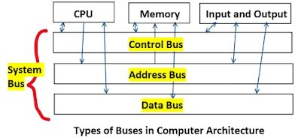
- Address Bus:

  - Address bus carry the memory address while reading from writing into memory.
  - Address bus caary I/O post address or device address from I/O port.
  - In uni-directional address bu only the CPU could send address and other units could not address the microprocessor.
  - Now a days computers are haing bi-directional address bus.

Data Bus:

  - Data bus carry the data.
  - Data bus is a bidirectional bus.
  - Data bus fetch the instructions from memory.

  - Data bus used to store the result of an instruction into memory.
  - Data bus carry commands to an I/O device controller or port.
  - Data bus carry data from a device controller or port.
- Data bus issue data to a device controller or port.

Control Bus:

Different types of control signals are used in a bus:

- Memory Read: This signal, is issued by the CPU or DMA controller when performing a read operation with the memory.
- MemoryWrite: This signal isissued by the CPU or DMAcontroller when performing a write operation with the memory.
- I/O Read: This signal isissued by the CPU when it is reading from an input port.
- I/O Write: This signal is issued by the CPU when writing into an output port.
- Ready: The ready is an input signal to the CPU generated in order to synchronize the show memory or I/O ports with the fast CPU.
A system bus is a single computer bus that connects the major components of a computer system, combining the functions of a data bus to carry information, an address bus to determine where it should be sent, and a control bus to determine its operation.

Computer Ports:_

A Computer Port is an interface or a point of connection between the computer and its peripheral devices. Some of the common peripherals are mouse, keyboard, monitor or display unit, printer, speaker, flash drive etc.

The main function of a computer port is to act as a point of attachment, where the cable from the peripheral can be plugged in and allows data to flow from and to the device.

A computer port is also called as a Communication Port as it is responsible for communication between the computer and its peripheral device. Generally, the female end of the connector is referred to as a port and it usually sits on the motherboard.

In Computers, communication ports can be divided into two types based on the type or protocol used for communication. They are Serial Ports and Parallel Ports.

A serial port is an interface through which peripherals can be connected using a serial protocol which involves the transmission of data one bit at a time over a single communication line. The most common type of serial port is a D- Subminiature or a D-sub connector that carry RS-232 signals.

A parallel port, on the other hand, is an interface through which the communication between a computer and its peripheral device is in a parallel manner i.e. data is transferred in or out in parallel using more than one communication line or wire. Printer port is an example of parallel port.

The article gives a brief introduction to different types of ports along with their a PS/2
PS/2 connector is developed by IBM for connecting mouse and keyboard. It was introduced with IBM’s Personal Systems/2 series of computers and hence the name PS/2 connector. PS/2 connectors are color coded as purple for keyboard and green for mouse.
applications.

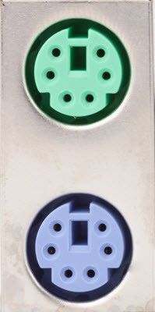

PS/2 is a 6-pin DIN connector. The pin out diagram of a PS/2 female connector is shown below.

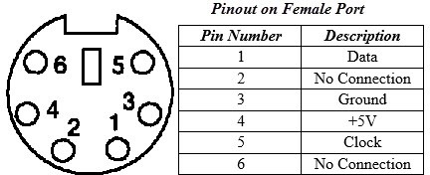

Even though the pinout of both mouse and keyboard PS/2 ports are same, computers do not recognize the devise when connected to wrong port.

PS/2 port is now considered a legacy port as USB port has superseded it and very few of the modern motherboards include it as a legacy port.
Serial Port
Even though the communication in PS/2 and USB is serial, technically, the term Serial Port is used to refer the interface that is compliant to RS-232 standard.

There are two types of serial ports that are commonly found on a computer: DB- 25 and DE-9.

DB-25
DB-25 is a variant of D-sub connector and is the original port for RS-232 serial communication. They were developed as the main port for serial connections using RS-232 protocol but most of the applications did not require all the pins.

Hence, DE-9 was developed for RS-232 based serial communication while DB- 25 was rarely used as a serial port and often used as a parallel printer port as a replacement of the Centronics Parallel 36 pin connector.

DE-9 or RS-232 or COM Port
DE-9 is the main port for RS-232 serial communication. It is a D-sub connector with E shell and is often miscalled as DB-9. A DE-9 port is also called as a COM port and allows full duplex serial communication between the computer and it’s peripheral.

Some of the applications of DE-9 port are serial interface with mouse, keyboard, modem, uninterruptible power supplies (UPS) and other external RS-232 compatible devices.
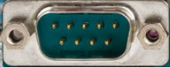
DE-9 Port

The pinout diagram of DE-9 port is shown below.

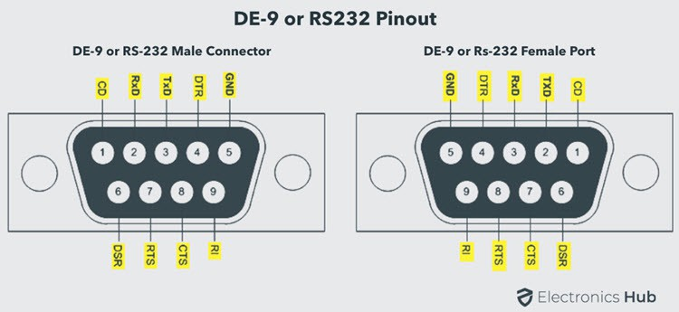
DE-9-RS-232-Male-Female-Pinout

The use of DB-25 and DE-9 ports for communication is in decline and are replaced by USBs or other ports.

Parallel Port or Centronics 36 Pin Port
Parallel port is an interface between computer and peripheral devices like printers with parallel communication. The Centronics port is a 36 pin port that was developed as an interface for printers and scanners and hence a parallel port is also called as a Centronics port.

Before the wide use of USB ports, parallel ports are very common in printers. The Centronics port was later replaced by DB-25 port with parallel interface.
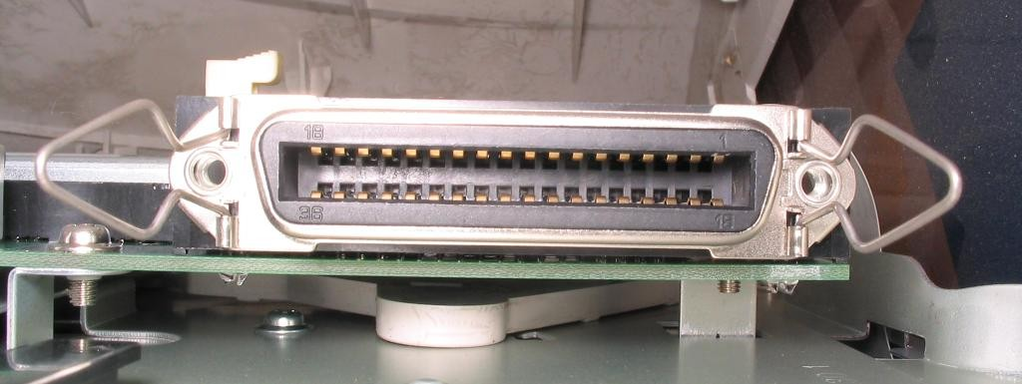

Audio Ports
Audio ports are used to connect speakers or other audio output devices with the computer. The audio signals can be either analogue or digital and depending on that the port and its corresponding connector differ.

Surround Sound Connectors or 3.5 mm TRS Connector
It is the most commonly found audio port that can be used to connect stereo headphones or surround sound channels. A 6 connector system is included on majority of computers for audio out as well as a microphone connection.

The 6 connectors are color coded as Blue, Lime, Pink, Orange, Black and Grey. These 6 connectors can be used for a surround sound configuration of up to 8 channels.
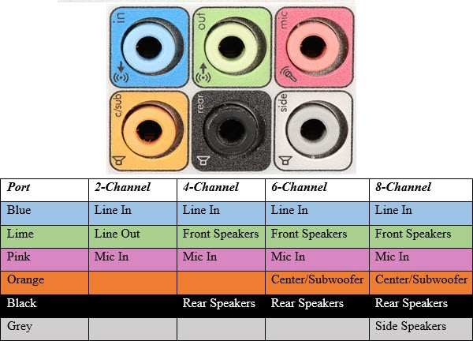
Surround Sound Ports
S/PDIF / TOSLINK 13

The Sony/Phillips Digital Interface Format (S/PDIF) is an audio interconnect used in home media. It supports digital audio and can be transmitted using a coaxial RCA Audio cable or an optical fiber TOSLINK connector.

Most computers home entertainment systems are equipped with S/PDIF over TOSLINK. TOSLINK (Toshiba Link) is most frequently used digital audio port that can support 7.1 channel surround sound with just one cable. In the following image, the port on the right is an S/PDIF port.
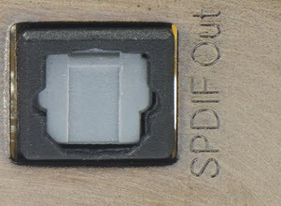
SPDIF Port

Video Ports VGA Port
VGA port is found in many computers, projectors, video cards and High Definition TVs. It is a D-sub connector consisting of 15 pins in 3 rows. The connector is called as DE-15.

VGA port is the main interface between computers and older CRT monitors. Even the modern LCD and LED monitors support VGA ports but the picture quality is reduced. VGA carries analogue video signals up to a resolution of 648X480.

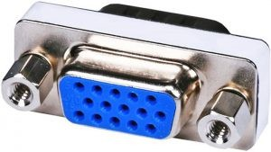
VGA Port

With the increase in use of digital video, VGA ports are gradually being replaced by HDMI and Display Ports. Some laptops are equipped with on-board VGA ports in order to connect to external monitors or projectors. The pinout of a VGA port is shown below.
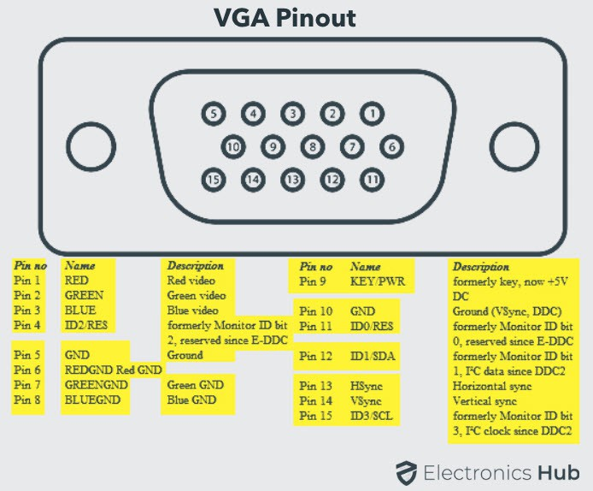
VGA-Port-Pinout

Digital Video Interface (DVI)

DVI is a high speed digital interface between a display controller like a computer and a display device like a monitor. It was developed with an aim of transmitting lossless digital video signals and replace the analogue VGA technology.
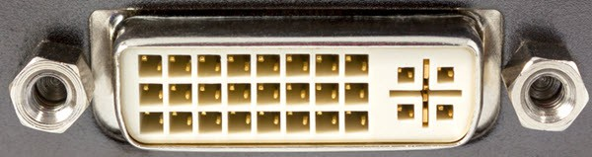

DVI Port

There are three types of DVI connectors based on the signals it can carry: DVI- I, DVI-D and DVI-A. DVI-I is a DVI port with integrated analogue and digital signals. DVI-D supports only digital signals and DVI-A supports only analogue signals.

The digital signals can be either single link or dual link where a single link supports a digital signal up to 1920X1080 resolution and a dual link supports a digital signal up to 2560X1600 resolution. The following image compares the structures of DVI-I, DVI-D and DVI-A types along with the pinouts.
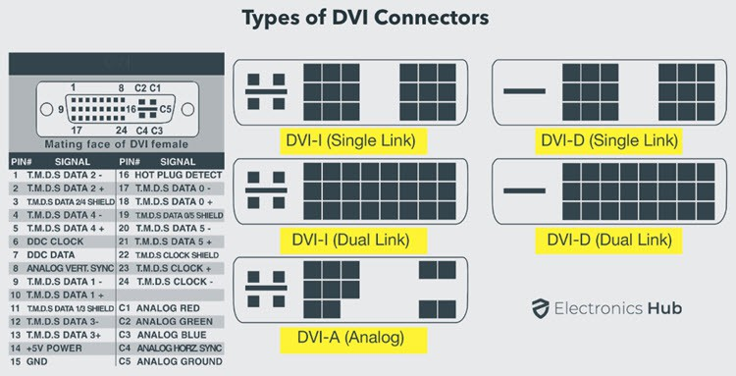
Types-of-DVI-Connectors-Pinout 20

Mini-DVI
Mini-DVI port is developed by Apple as an alternative to Mini-VGA port and is physically similar to one. It is smaller than a regular DVI port.

It is a 32 pin port and is capable of transmitting DVI, composite, S-Video and VGA signals with respective adapters. The following image shows a Mini-DVI port and its compatible cable.
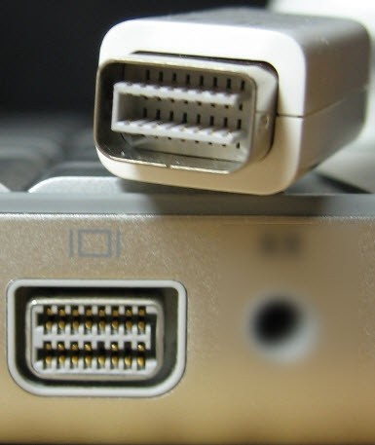
Mini DVI Port

Micro-DVI
Micro-DVI port, as the name suggests is physically smaller than Mini-DVI and is capable of transmitting only digital signals.
This port can be connected to external devices with DVI and VGA interfaces and respective adapters are required. In the following image, a Micro-DVI port can be seen adjacent to headphone and USB ports.

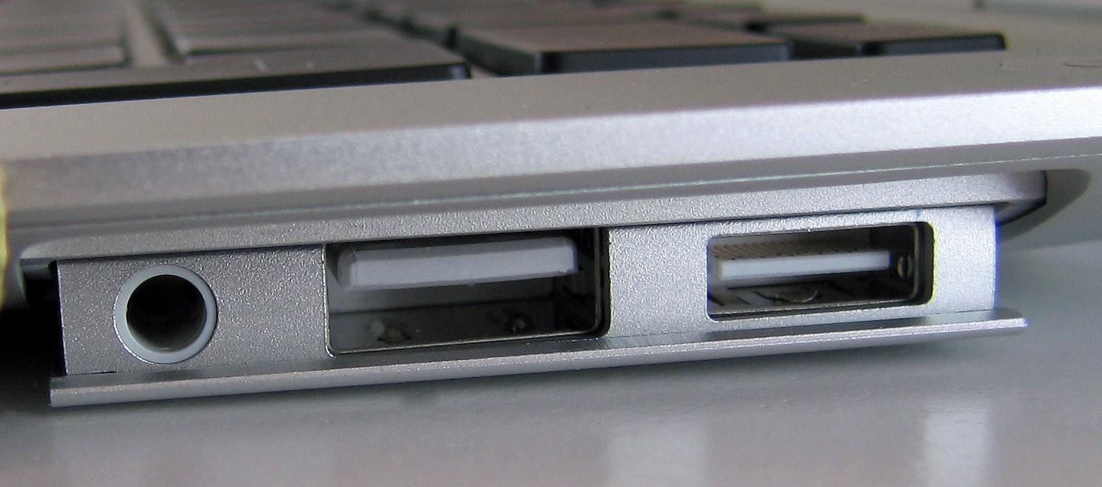

Display Port
Display Port is a digital display interface with optional multiple channel audio and other forms of data. Display Port is developed with an aim of replacing VGA and DVI ports as the main interface between a computer and monitor.

The latest version DisplayPort 1.3 can handle a resolution up to 7680 X 4320.

The Display Port has a 20 pin connector, which is a very less number when compared to DVI port and offers better resolution. The pin out diagram of a Display Port is shown below.

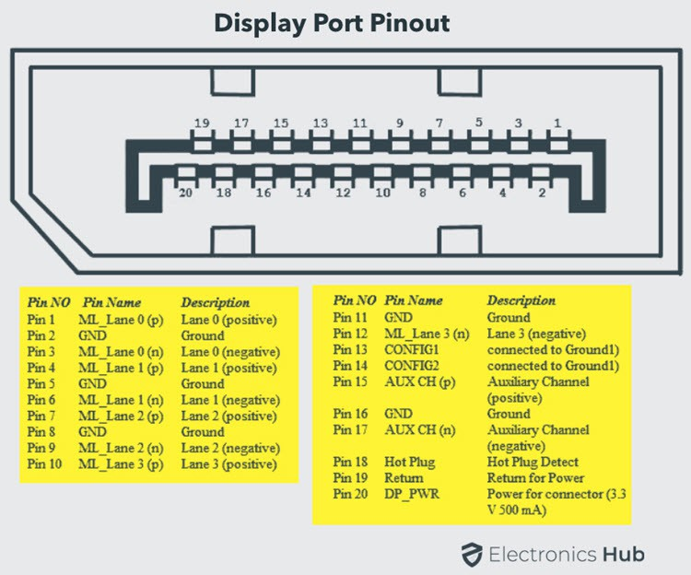
Display-Port-Pinout

Update: DisplayPort 1.4a is the latest (in production) version of DisplayPort Specification with support for 4K (3840 x 2160) at 120 Hz or 8K (7680 x 4320) at 60 Hz. An improved DisplayPort version 2.0 specification is released in June of 2019 with an increased bandwidth of 77.37 Gbps (approximately).

Mini DisplayPort

Apple introduced a miniature version of DisplayPort and called it Mini DisplayPort (mDP or Mini DP). Even though Mini DisplayPort has 20 pins, the physical size of the connector is smaller than a regular DisplayPort and the pin out is also different.

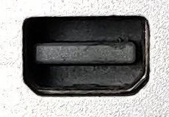
Mini DisplayPort

Most laptops provide Mini DisplayPort as an additional video out option in addition to HDMI.

RCA Connector
RCA Connector can carry composite video and stereo audio signals over three cables. Composite video transmits analogue video signals and the connector is as yellow colored RCA connector.

The video signals are transmitted over a single channel along with the line and frame synchronization pulses at a maximum resolution of 576i (standard resolution).

The red and white connectors are used for stereo audio signals (red for right channel and white for left channel).

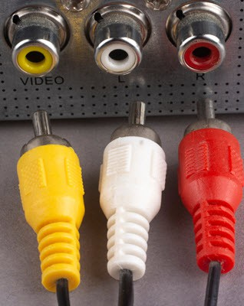
RCA Port

Component Video
Component Video is an interface where the video signals are split into more than two channels and the quality of the video signal is better that Composite video.

Like composite video, component video transmits only video signals and two separate connectors must be used for stereo audio. Component video port can transmit both analogue and digital video signals.

The ports of the commonly found Component video uses 3 connectors and are color coded as Green, Blue and Red.

S-Video
S-Video or Separate Video connector is used for transmitting only video signals. The picture quality is better than that of Composite video but has a lesser resolution than Component video.

The S-Video port is generally black in color and is present on all TVs and most computers. S-Video port looks like a PS/2 port but consists of only 4 pins.
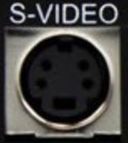
S Video

Out of the 4 pins, one pin is used to carry the intensity signals (black and white) and other pin is used to carry color signals. Both these pins have their respective ground pins. The pinout diagram of an S-Video port is shown below.

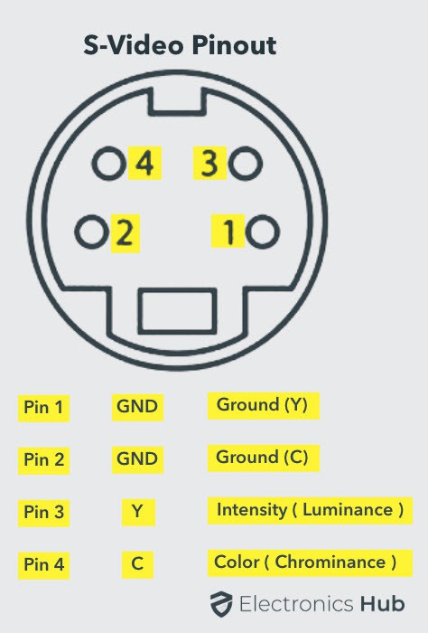
S-Video-Port-Pinout HDMI
HDMI is an abbreviation of High Definition Media Interface. HDMI is a digital interface to connect High Definition and Ultra High Definition devices like Computer monitors, HDTVs, Blu-Ray players, gaming consoles, High Definition Cameras etc.

HDMI can be used to carry uncompressed video and compressed or uncompressed audio signals. The HDMI port of type A is shown below.

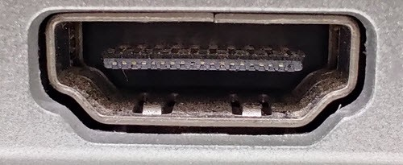
HDMI Port

The HDMI connector consists of 19 pins and the latest version of HDMI i.e. HDMI 2.0 can carry digital video signal up to a resolution of 4096×2160 and 32 audio channels. The pinout diagram of an HDMI port is as follows.

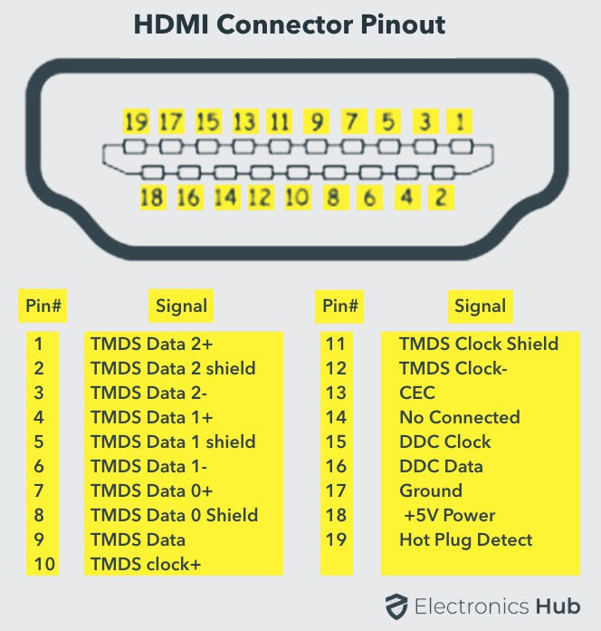
HDMI-Port-Pinout

Update: The latest version of HDMI is 2.1 with much improved bandwidth, resolution and support from video card manufacturers. While HDMI 2.0 has a data bandwidth of 18 Gbps, the HDMI 2.1 has a staggering 48 Gbps of bandwidth. Coming to the display resolution, HDMI 2.1 supports 4K and 8K at 120 Hz refresh rate. Most modern (at least high end) graphics cards like Nvidia RTX 3090 provide at least a couple of HDMI 2.1 Ports to connect with monitors and TVs.

MINI HDMI:
With HDMI 1.3 Version, a new HDMI Port and Connector combination is released called the Mini HDMI. Physically, it is smaller than a regular HDMI Port but has same 19 Pin. Intended for portable devices like laptops, cameras, camcorders, the Mini HDMI Port isn’t that popular.

Micro HDMI
HDMI developers introduced a new HDMI Connector and Port called Micro HDMI with HDMI Version 1.4. Micro HDMI also has 19 pins (just like regular HDMI and Mini HDMI) but the pinout is different.

Micro HDMI is often used in cameras, single board computers (like Raspberry Pi 4), etc. where physically it is difficult to include a regular HDMI port.
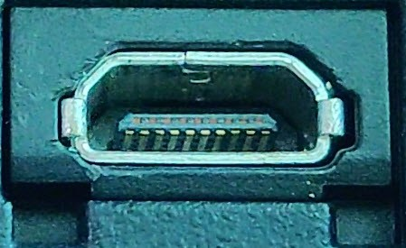

Micro HDMI Port

The size of Micro HDMI is significantly smaller than regular HDMI and has some resemblance to a micro–USB Port (sometimes people confuse among the two). The port on the left is a micro USB port and the one on the right is a micro HDMI Port.

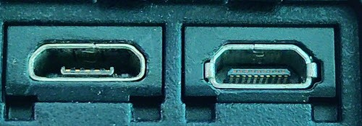

Micro USB and Micro HDMI

USB
Universal Serial Bus (USB) replaced serial ports, parallel ports, PS/2 connectors, game ports and power chargers for portable devices.

USB port can be used to transfer data, act as an interface for peripherals and even act as power supply for devices connected to it. There are three kinds of USB ports: Type A, Type B or mini USB and Micro USB.

USB Type A
USB Type-A port is a 4 pin connector. There are different versions of Type – A USB ports: USB 1.1, USB 2.0 and USB 3.0. USB 3.0 is the common standard and supports a data rate of 400MBps.

USB 3.1 is also released and supports a data rate up to 10Gbps. Usually, but not all the times, the USB 2.0 is Black color coded and USB 3.0 is Blue. The following image shows USB 2.0 and USB 3.0 ports.
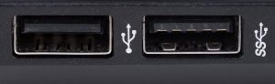
USB 2.0 and USB 3.0 31

The pinout diagram of USB Type – A port is shown below. The pinout is common to all standards of Type – A.
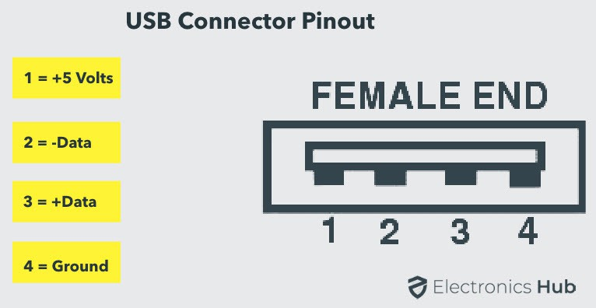
USB-Type-A-Connector-Pinout

USB Type C
USB Type – C is the latest specification of the USB and is a reversible connector. USB Type – C is supposed to replace Types A and B and is considered future proof.
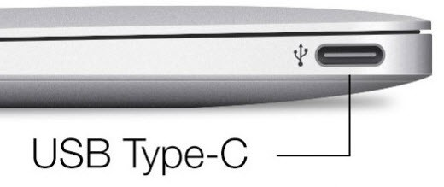

USB Type C

The port of USB Type – C consists of 24 pins. The pinout diagram of USB Type – C is shown below. The latest USB Specifications (USB4) is an USB-C only specification i.e., only USB type C devices can be used with USB4 specifications.
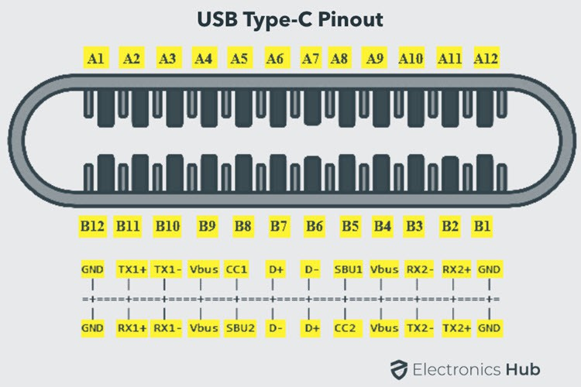
USB-Type-C-Port-Pinout

In the latest USB4 specification, USB Type C Devices can support speeds up to 40 Gbps.

USB Power Delivery specifications allow USB devices to supply power to devices connected to the USB Port. USB Type – C can handle a current of 5A at 20V (only Power Delivery certified USB Type-C Ports).

This feature of handling high current is used in the latest Fast Charging Technology where a Smart Phone’s battery will reach its full charge is very less time. So, USB Type C Ports can provide up to 100W of power (which can be used for charging mobile phones and laptops).

In fact, the latest Apple M1 Mac Books use 61W USB C Power Adapter.

RJ-45
Ethernet is a networking technology that is used to connect your computer to Internet and communicate with other computers or networking devices.

The interface that is used for computer networking and telecommunications is known as Registered Jack (RJ) and RJ – 45 port in particular is used for Ethernet over cable. RJ-45 connector is an 8 pin – 8 contact (8P – 8C) type modular connector.

The latest Ethernet technology is called Gigabit Ethernet and supports a data transfer rate of over 10Gigabits per second. The Ethernet or a LAN port with 8P – 8C type connector along with the male RJ-45 cable is shown below.

The un-keyed 8P – 8C modular connector is generally referred to the Ethernet RJ-45. Often, RJ-45 ports are equipped with two LEDs for indicating transmission and packet detection.
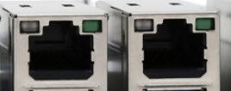
RJ45 Port

As mentioned earlier, an Ethernet RJ-45 port has 8 pins and the following picture depicts the pinout of one.

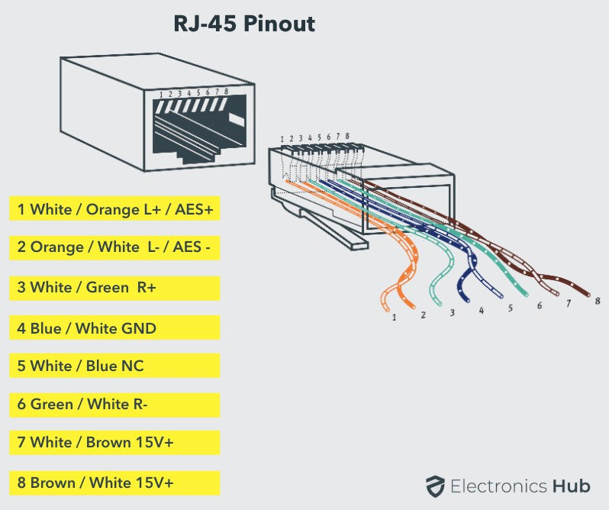
RJ-45-Connector-Pinout

RJ-11
RJ-11 is another type of Registered Jack that is used as an interface for telephone, modem or ADSL connections. Even though computers are almost never equipped with an RJ-11 port, they are the main interface in all telecommunication networks.

RJ-45 and RJ11 ports look alike but RJ-11 is a smaller port and uses a 6 point – 4 contact (6P – 4C) connector even though a 6 point – 2 contact (6P – 2C) is sufficient. The following is a picture of an RJ-11 port and its compatible connector.

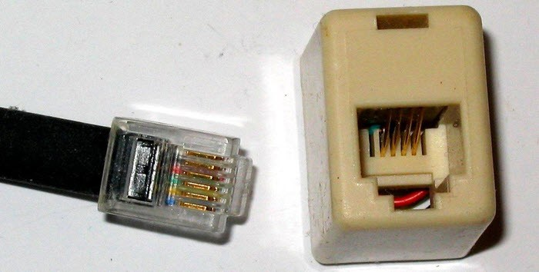
RJ11 Port and Connector

The following image can be used to compare RJ-45 and RJ-11 ports.
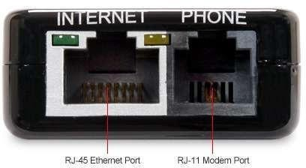

e-SATA
e-SATA is an external Serial AT Attachment connector that is used as an interface for connecting external mass storage devices. Modern e-SATA connector are called e-SATAp and stands for Power e-SATA ports.

They are hybrid ports capable of supporting both e-SATA and USB. Neither the SATA organization nor the USB organization has officially approved the e- SATAp port and must be used at user’s risk.

The above image is of an e-SATAp port. It shows that both e-SATA and USB devices can be connected.

Computer connections and related colors

The list below includes many ports and their associated colors. These colors may be on the computer port, around the port, on the cable, or the plug.
Keyboard (PS/2) – Purple Mouse (PS/2) – Green Serial – Cyan
Printer – Violet Monitor (VGA) – Blue Monitor (DVI) – White
Line out (headphones) – Lime Green Line in (microphone) – Pink
Audio in – Grey Joystick – Yellow
- Further Learning:
Use the color-coded diagram as a reference while exploring more complex motherboard designs or when studying the internal architecture of computers.
Safety Tips:
Avoid handling electronic components directly if working with an actual motherboard.
If handling a real motherboard, ensure static electricity is discharged before touching any components.This experiment offers a practical and visual approach to understanding mothe color-coded diagram. It encourages hands-on learning and facilitates a clearer understanding of how various elements interact within the motherboard.rboard components, expansion slots, bus structures, and ports using a

EXPERIMENT-3
Aim: Study of functioning of SMPS with o/p voltage and connector
Studying the functioning of an SMPS (Switched-Mode Power Supply) can be insightful, especially understanding its output voltages and connectors. Here's a basic experiment to help:
Materials Needed:
SMPS Unit: A spare or old SMPS for examination. Multimeter: For measuring output voltages.
Load (optional): A simple electronic load, like resistors, for testing.
Guide or References: Online resources or guides explaining SMPS functions and connectors.
Experiment Steps:
  - Safety Precautions:
Ensure the SMPS is unplugged from any power source before proceeding. Handle the SMPS with care to avoid electrical shock.
  - Examination of Connectors:
Identify the connectors on the SMPS: ATX, CPU power, SATA, Molex, etc.
Refer to guides or online resources to understand the purpose of each connector.
  - Measuring Output Voltages:
Connect the multimeter to the output pins of the SMPS connectors. Set the multimeter to the appropriate voltage range.
Power on the SMPS while observing safety precautions.
Measure and note the output voltages across different connectors (e.g., +12V,
+5V, +3.3V).

  - Load Testing (Optional):
If using an electronic load:
Connect the load to one of the output connectors of the SMPS.
Observe how the voltage changes or remains stable when the load is applied or removed.
  - Understanding Output Voltage Levels:
Compare the measured voltages with standard values for the respective connectors.
Discuss the significance of different voltage levels and their relevance to various computer components.
  - Connector Functions and Compatibility:
Explore the purpose of each connector, understanding which components they power and their compatibility with devices like motherboards, drives, or graphics cards.
The color codes used in the wiring of an SMPS (Switched-Mode Power Supply) aren't standardized globally. However, there are some common practices and conventions followed by manufacturers. Here's a general guideline for voltage outputs and their associated wire colors in some SMPS units:
ATX Power Supply Connectors:
20/24-pin ATX Main Power Connector:
Orange (+3.3V) Red (+5V)
Yellow (+12V) Black (Ground) Blue (-12V)
White (-5V, rarely used) - Note: Modern PSUs often omit this wire. Purple (+5V Standby)
Green (PS_ON) Gray (Power_OK)
CPU Power Connector (4/8-pin): 40

Yellow (+12V) Black (Ground)
Peripheral Connectors (SATA, Molex):
Red (+5V)
Yellow (+12V) Black (Ground)
Color Coding Conventions:
Red: Typically used for +5V. Yellow: Often used for +12V.
Orange: Commonly associated with +3.3V. Black: Represents Ground (0V).
Other colors like blue, green, purple, and gray are used for specific functions or signaling purposes.
  - Safety and Conclusion:
Power off the SMPS and disconnect it from any power source.
Conclude the experiment with a summary of the observed output voltages, their importance, and the functions of different connectors.
Safety Tips:
Handle electrical components with care and follow safety protocols. Never tamper with an SMPS while it's connected to a power source.
This experiment offers hands-on learning about SMPS output voltages, connector functionalities, and their importance in powering various components of a computer system. Always prioritize safety while working with electrical components.

EXPERIMENT-4
Aim: Study of HDD Interfaces

Studying HDD (Hard Disk Drive) interfaces can offer insights into how storage devices connect to computers. Here's an experiment to help you understand different HDD interfaces:
Materials Needed:
Hard Disk Drives: Different HDDs with various interfaces (e.g., SATA, IDE/PATA).
Computer System: A computer or laptop with compatible ports for HDD connections.
Screwdriver: For mounting HDDs if needed.
Guide or References: Online resources or guides explaining HDD interfaces. Experiment Steps:
    - Understanding Interface Types:
Learn about different HDD interface types: SATA, IDE/PATA, SCSI (if available), M.2, NVMe, etc. Research their history, features, and compatibility.
    - Examination of HDDs:
Gather HDDs with different interfaces (e.g., SATA HDD, IDE/PATA HDD, M.2 SSD).
Examine each HDD closely, noting their connectors and interface types.
    - Connecting HDDs:
If using a desktop system:
Power off and unplug the computer.
Open the computer case using a screwdriver.
Connect the HDDs to the appropriate ports: SATA ports for SATA HDDs, IDE ports for IDE/PATA HDDs, etc.
Securely mount the HDDs in the drive bays.
    - Laptop or External Enclosure (if applicable):
For laptops or external enclosures:
Connect the HDDs to the appropriate ports or enclosures.
Follow the manufacturer's instructions if using an external enclosure.
    - System Boot-Up and Recognition:
Power on the computer system.
Enter the BIOS/UEFI settings (if necessary) to check if the connected HDDs are recognized by the system.
    - Data Transfer (if applicable):
If the HDDs are recognized:
Explore the connected HDDs through the operating system.
Transfer some data/files to and from the HDDs to ensure functionality.
42

    - Comparison and Discussion:
Compare the speeds, compatibility, and ease of use between different interfaces.

Discuss the advantages and limitations of each interface type. Safety Tips:
Always handle HDDs with care to avoid physical damage.
Ensure proper grounding and follow static electricity precautions when handling electronic components.
This experiment allows hands-on exploration of different HDD interfaces, enabling a better understanding of how various storage devices connect to computer systems. It also provides insights into their compatibility, functionality, and usage within computer hardware.

EXPERIMENT-5
Aim: Connecting hardware components for assembly of Computer Absolutely, assembling a computer is a fantastic hands-on experiment that
helps you understand how hardware components are interconnected to create
a functional system. Here's a step-by-step guide:
Materials Needed:
Computer Components: CPU, motherboard, RAM, storage (HDD/SSD), PSU, GPU (if using a dedicated graphics card), case, etc.
Screwdriver: To secure components.
Thermal Paste (if needed): Required for CPU installation (sometimes included with the CPU cooler).
Guide or References: Online tutorials or manuals for component assembly. Experiment Steps:
- Workspace Setup:
Choose a clean, static-free workspace with enough room to lay out the components.
Ensure good lighting for visibility.
- Preparing the Case:
Open the computer case by removing the side panels.
Place the case horizontally for easy access to the internal components.
- Mounting the Power Supply Unit (PSU):
Install the PSU in the designated area of the case, securing it with screws.
- Installing the Motherboard:
Align the motherboard with the case standoffs to fit into the I/O shield. Secure the motherboard to the case using screws.
- Mounting the CPU:
Follow the motherboard manual's instructions to correctly install the CPU into the CPU socket.
Apply thermal paste (if necessary) and attach the CPU cooler, ensuring it's properly seated and secured.
- Adding RAM:
Insert the RAM modules into the designated slots on the motherboard. Ensure the RAM is aligned correctly and firmly seated until the retention clips click into place.
- Connecting Storage Drives:
Install the HDDs or SSDs into the drive bays, securing them with screws if needed.
Connect the SATA or power cables to the drives and motherboard.
- Adding Expansion Cards (GPU, etc.):
If using a dedicated GPU, insert it into the appropriate PCIe slot on the motherboard and secure it with screws.
Connect any additional power cables required for the GPU.
- Cable Management:
44

Organize and route cables neatly to ensure good airflow and a clean look inside the case.

Connect power supply cables to the motherboard, GPU, drives, etc.
- Final Checks and Boot-Up:
Double-check all connections and components for proper installation. Close the case and secure the side panels.
Connect the monitor, keyboard, mouse, and power cable.
Power on the system to check if it boots up and displays the BIOS/UEFI screen.
Safety Tips:
Handle components delicately to avoid damage.
Power off and unplug the system before installation and avoid static discharge by grounding yourself.
Assembling a computer provides a comprehensive understanding of hardware components, their connections, and how they work together to form a functional system. Following guidelines and manuals ensures a smooth assembly process.

EXPERIMENT-6

Aim: Setting up of CMOS
Certainly! Setting up the CMOS (Complementary Metal-OxideSemiconductor) or BIOS/UEFI settings in a practical lab environment involves accessing the system's firmware and configuring various parameters. Here's a step-by-step guide:

Materials Needed:
Computer System: A desktop or laptop.
Keyboard and Mouse: Input devices to navigate the BIOS/UEFI interface. Monitor: To display the BIOS/UEFI interface.
Guide or References: Documentation or online resources explaining BIOS/UEFI settings.
Experiment Steps:
- Accessing BIOS/UEFI:
Power on the computer system.
Press the designated key to enter the BIOS/UEFI interface (common keys: Del, F2, F10, F12; varies among manufacturers).
Alternatively, some systems might display a prompt on the screen to press a specific key to access BIOS/UEFI.
- Navigating BIOS/UEFI Interface:
Use the keyboard to navigate through the BIOS/UEFI menus and options. Explore the different sections and settings available. Common sections include:
Main: Basic system information.
Advanced: Advanced settings for CPU, RAM, etc. Boot: Boot device priority configuration.
Security: Security-related settings.
Exit: Save or discard changes and exit BIOS/UEFI.
- Configuring Settings:
Experiment with changing settings within the BIOS/UEFI. Examples include: Boot Order: Change the sequence of boot devices (HDD, SSD, USB, etc.). Overclocking (if supported): Adjust CPU or RAM clock speeds.
Power Management: Configure power-saving features. Hardware Monitoring: Check temperature or voltage settings.
Security Options: Password settings or secure boot configurations.
- Making Changes and Saving:
When adjusting settings, follow on-screen instructions to make changes. Be cautious with changes, as incorrect configurations might affect system stability.
46

- Saving and Exiting:
After making changes, navigate to the "Exit" or similar section.

Choose "Save Changes and Exit" to apply the modifications and reboot the system.
- Verifying Changes:
After rebooting, ensure that the changes you made are reflected in the system behavior.
For instance, check if the boot order has changed or if power management settings are applied.
Safety Tips:
Follow the on-screen instructions carefully to avoid unintended changes. Do not change settings unless you understand their implications.
Note:
For a comprehensive understanding, explore each setting's function and its impact on system performance, stability, and security.
Take caution when modifying settings related to hardware or system behavior, as incorrect configurations may cause system instability or even damage.
This practical lab provides hands-on experience in navigating and configuring the BIOS/UEFI settings, offering insights into system configurations and options available for customization.

EXPERIMENT-7
Aim: Installing OS.
Installing an operating system (OS) is a crucial step in setting up a computer. Here's a guide for a practical lab on installing an OS like Windows:
Materials Needed:
Computer System: Desktop or laptop.
OS Installation Media: Windows installation USB/DVD. Product Key (if required): For activating Windows.
Guide or References: Installation guides or online tutorials for the specific OS. Experiment Steps:
- Pre-Installation Preparation:
Ensure important data is backed up from the target drive (if applicable) as the installation might erase existing data.
Insert the Windows installation USB or DVD into the computer.
- Booting from Installation Media:
Power on the computer system.
Access the BIOS/UEFI by pressing the designated key during startup (common keys: Del, F2, F10, F12).
In the BIOS/UEFI, set the boot priority to the installation media (USB/DVD) to boot from it.
Save and exit BIOS/UEFI, restarting the system.
- Windows Setup:
The system boots from the installation media and loads the Windows Setup.
Follow on-screen instructions to select language, time format, and keyboard/input method.
Click "Install Now" to begin the installation process.
5. Enter Product Key and Select Edition

:

Enter the Windows product key if prompted. Otherwise, proceed without entering a key (an option during setup).
Choose the Windows edition you want to install (e.g., Windows 10 Home, Pro).
- Accept License Terms and Choose Installation Type:
Agree to the license terms and click "Next."
Select the installation type: "Custom" (for a clean installation) or "Upgrade" (to keep existing files).
- Partitioning and Drive Selection:
If doing a custom installation, select the drive where you want to install Windows.
Format the selected drive or create/delete partitions as needed.
- Installation Progress:
The installation process begins, and the system reboots multiple times during installation.
Follow on-screen prompts to set preferences like region, language, and account settings.
- Post-Installation Setup:
After the installation completes, set up user accounts, passwords, and system preferences.
Install necessary drivers for hardware components like graphics, sound, and network cards.
- Activation and Updates:
Activate Windows using the product key if required.
Check for and install Windows updates to ensure the system is up-to-date.
- Verification:
Verify that Windows has been successfully installed and is running properly. Test basic functionalities like internet connectivity, sound, and display.
Safety Tips: 49

Always use legal and licensed copies of the OS.

Ensure data backups to prevent loss during installation.
This practical lab offers hands-on experience in installing an operating system, covering the entire process from booting through the installation steps to post- installation setup. Following guides and paying attention to on-screen instructions ensures a smooth installation process.

EXPERIMENT-8

Aim: Installing different software
Installing different software applications is a fundamental aspect of setting up a computer. Here's a guide for a practical lab on installing software:

Materials Needed:
Computer System: Desktop or laptop.
Internet Connection: Required for downloading software (if not pre- downloaded).
Software Installation Files: Downloaded or obtained from official sources.
Guide or References: Installation guides or online tutorials for specific software, if available.
Experiment Steps:
- Identify Software:
Decide on the software to install (e.g., web browser, office suite, media player, antivirus).
Download the software installation files from official websites or secure sources.
- Installation Process:
Launch the installation file by double-clicking or running the setup file. Follow on-screen instructions provided by the software installer.
- Customization (if available):
Some software installations offer customization options during the setup process:
Choose installation location (if applicable).
Select additional components or features to install. Set preferences or configure settings as needed.
51

- Accept Terms and Install:

Review and accept license agreements or terms of use if prompted. Click "Install" or similar to begin the installation process.
- Progress and Completion:
Wait for the installation process to complete. This may take a few moments to several minutes, depending on the software size and complexity.
- Post-Installation Options:
Some software installations might offer additional options after installation: Launch the software automatically after installation.
Create desktop shortcuts or start menu entries.
- Verification and Testing:
Once installed, open the software to verify it runs properly.
Test basic functionalities to ensure the software operates as expected.
- Repeat for Other Software:
Repeat the installation process for other software applications as needed. Safety Tips:
Download software from official or reputable sources to avoid malware or security risks.
Pay attention to checkboxes during installation to avoid installing additional, unwanted software (bundled software).
Note:

Some software may have specific installation requirements or additional steps. Always refer to installation guides or instructions provided by the software vendor for accurate installation procedures.

This practical lab provides hands-on experience in installing various software applications, familiarizing you with the installation process, customization options, and verification of software functionality. Following installation guides ensures a smooth and error-free installation experience.

EXPERIMENT-9
Aim: Study different BIOS setup and different

BIOS (Basic Input/Output System) or UEFI (Unified Extensible Firmware Interface) setups can vary based on manufacturers and motherboard models. However, they generally share common functionalities and settings. Let's explore:

Common BIOS/UEFI Setup Options:
- Boot Options:
Boot Order: Specify the sequence in which devices boot (HDD/SSD, USB, CD/DVD drive).
UEFI/CSM: Choose between UEFI or Legacy BIOS boot mode.
- System Configuration:
Date and Time: Set system date and time.
SATA Mode: Configure SATA controllers (AHCI, RAID, IDE modes). Virtualization: Enable/disable hardware virtualization (Intel VT-x, AMD-V).
- Advanced Settings:
CPU Configuration: Modify CPU-related settings (clock speeds, hyper- threading).
RAM Configuration: Adjust memory timings, frequencies, or XMP profiles.
Hardware Monitoring: Check system temperatures, voltages, and fan speeds.
Power Management: Control power-saving features (CPU power states, sleep modes).
- Security Options:
Secure Boot: Enable/disable Secure Boot to ensure boot loader security. TPM (Trusted Platform Module): Manage TPM settings if available.

- Peripherals:
USB Configuration: Enable/disable USB ports, adjust USB power settings. Onboard Devices: Enable/disable onboard devices (audio, LAN, Wi-Fi).
- UEFI Settings:
UEFI Firmware Settings: Access UEFI settings from within Windows. UEFI Boot Order: Modify boot order specifically for UEFI devices.
Differences Among BIOS/UEFI:
Layout and Interface: BIOS/UEFI interfaces can differ in appearance and navigation styles.
Features and Options: Manufacturers might include unique or advanced settings specific to their motherboard models.
UEFI Specifics: UEFI BIOS tends to have more graphical interfaces and supports larger hard drives (due to GPT partitioning).
Compatibility: Legacy BIOS might have fewer features but better compatibility with older hardware and operating systems.
Experiment Suggestions:
Explore the BIOS/UEFI of different systems if available to compare layouts and options.
Study documentation or online resources provided by motherboard manufacturers for detailed insights into specific BIOS/UEFI settings.
Safety Tips:
Exercise caution when modifying settings; incorrect changes can affect system stability.
Avoid changing settings if you're unsure of their implications.
Studying different BIOS/UEFI setups offers insight into how system configurations are managed and allows users to customize hardware settings according to specific requirements. Experimenting with various setups helps in understanding the functionalities and variations among different BIOS/UEFI interfaces.

EXPERIMENT-10
Aim: Perform trouble shooting in Desktop and Laptop.

Troubleshooting issues with desktops and laptops involves identifying and addressing common problems users might encounter. Let's conduct a hands-on troubleshooting experiment:
Materials Needed:
Desktop Computer and Laptop: Both should have operational issues to troubleshoot.
Power Cables and Charger: Ensure both devices have power sources. Peripherals: Keyboard, mouse, monitor (if troubleshooting desktop), etc. Screwdriver (if needed): For accessing internal components.
Internet Access: Useful for looking up solutions or drivers.
Reference Materials: Troubleshooting guides or manufacturer's documentation. Troubleshooting Steps:
- Identifying Issues:
Start by listing the problems observed in both the desktop and laptop. Example: no power, no display, overheating, slow performance, etc.
- Initial Checks:
Power Supply: Ensure power sources (outlets, battery, PSU) are functional and devices are receiving power.
Peripherals: Check connections of keyboard, mouse, monitor, etc., to the respective devices.
- Boot and Observe:
Power on both devices and observe any error messages, unusual sounds (like beeps), or unexpected behavior during boot-up.
- Isolate Hardware vs. Software Issues:
Try booting into Safe Mode (if applicable) to isolate software-related problems.
56

If hardware issues are suspected, listen for unusual noises, check for overheating, or visually inspect internal components.
- Diagnostic Tools and Resources:
Use built-in diagnostic tools (like Windows Diagnostic Tools) to identify hardware problems.
Search online forums or the manufacturer's website for specific troubleshooting steps related to observed issues.
- Testing Components:
If possible, conduct tests on individual hardware components (RAM, hard drive, GPU) to identify faulty parts.
- System Updates and Driver Checks:
Update drivers and perform system updates for both devices if software-related issues are suspected.
- Documentation and Notes:
Take notes on observed symptoms, attempted solutions, and outcomes for future reference.
- Professional Assistance:
If unable to identify or resolve the issue, consider seeking help from a professional technician or the manufacturer's support.
Safety Tips:
Power off devices and disconnect them from power sources before troubleshooting internal components.
Handle hardware components carefully to avoid damage. Experiment Outcome:
This hands-on experiment will provide insight into the troubleshooting process, allowing you to diagnose and address common issues with desktops and laptops. By following systematic troubleshooting steps, you'll gain practical experience in identifying and resolving technical problems encountered with these devices.
57

